You have a data structure of employee information, including the employee's unique ID, importance value, and direct subordinates' IDs.

You are given an array of employees employees where:

* employees[i].id is the ID of the ith employee.
* employees[i].importance is the importance value of the ith employee.
* employees[i].subordinates is a list of the IDs of the direct subordinates of the ith employee.

Given an integer id that represents an employee's ID, return *the****total****importance value of this employee and all their direct and indirect subordinates*.

**Example 1:**

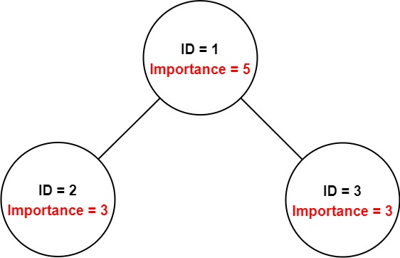

**Input:** employees = [[1,5,[2,3]],[2,3,[]],[3,3,[]]], id = 1

**Output:** 11

**Explanation:** Employee 1 has an importance value of 5 and has two direct subordinates: employee 2 and employee 3.

They both have an importance value of 3.

Thus, the total importance value of employee 1 is 5 + 3 + 3 = 11.

**Example 2:**

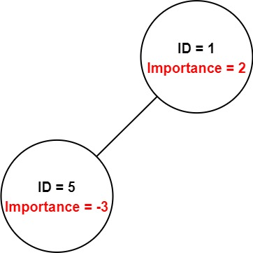

**Input:** employees = [[1,2,[5]],[5,-3,[]]], id = 5

**Output:** -3

**Explanation:** Employee 5 has an importance value of -3 and has no direct subordinates.

Thus, the total importance value of employee 5 is -3.

**Constraints:**

* 1 <= employees.length <= 2000
* 1 <= employees[i].id <= 2000
* All employees[i].id are **unique**.
* -100 <= employees[i].importance <= 100
* One employee has at most one direct leader and may have several subordinates.
* The IDs in employees[i].subordinates are valid IDs.